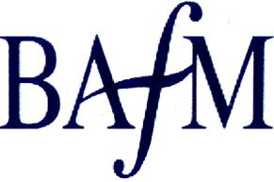
BAFM Wales Regional Meeting
Tuesday, July 17th, 2018
at Nantgarw China Works, Cardiff
The cost of the day will be £15 which includes lunch.
BOOKING FORM

Name:
Organisation:

e-mail address:

Address:

Special Dietary Requirements:

I enclose a cheque for £15. Please make cheques payable to:-
The Friends Royal Welsh Regimental Museum.
Please send cheque and form (above) to: Dorcas Cresswell, The Royal Welsh Regimental Museum, The Barracks, Brecon, Powys LD3 7EB.
Please send payment notification to: dorcascresswell@gmail.com

