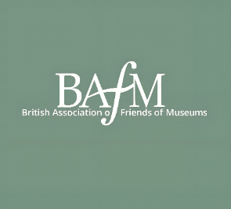
In Association with the Marsh Charitable Trust
Individual Volunteer of the Year Award 2026
This year sees the introduction of a new award to be made by The British Association of Friends of Museums. We are all aware of the immense contributions made by members of our affiliated groups to the development and smooth running of their Friends Group. The Marsh Charitable Trust are especially keen to recognise the work of individuals and have agreed to award a cheque for £250 to the person deemed to have offered the most during their membership of BAFM or one of its affiliated groups. We have in mind a range of roles which could be recognised. It may be for someone who has for many years acted in an official capacity or simply someone who has provided tea/coffee and biscuits at meetings for their group. Alternatively, it may be someone who has made a significant input over a shorter period. Members may recall a few years ago when BAFM awarded an ‘Impact Award’ for groups. In a way, this new award seeks to replicate this type of award but this time for an individual.
There are three sources of recommendations for this award;
- It may be that someone who volunteers directly for BAFM may be recommended by anyone associated with BAFM or its affiliated groups
- A member of an affiliated group may by recommended by either another member/s
- A member of a volunteering programme run by a museum with a Friends Group affiliated to BAFM (The recommendation must come from the Friends Group)
To submit a recommendation for this award, the judges will accept a simple letter of recommendation (of no more than 2 sides of A4). Please include details of the person you are nominating and why they would make worthy winners. Also complete the form which goes along with the submission

Please complete this submission either by post or digitally by 30th June 2026
David Adgar , 6 Winnery Close Tickhill Doncaster DN11 9JT
Or digitally nrewspexard@outlook.com

